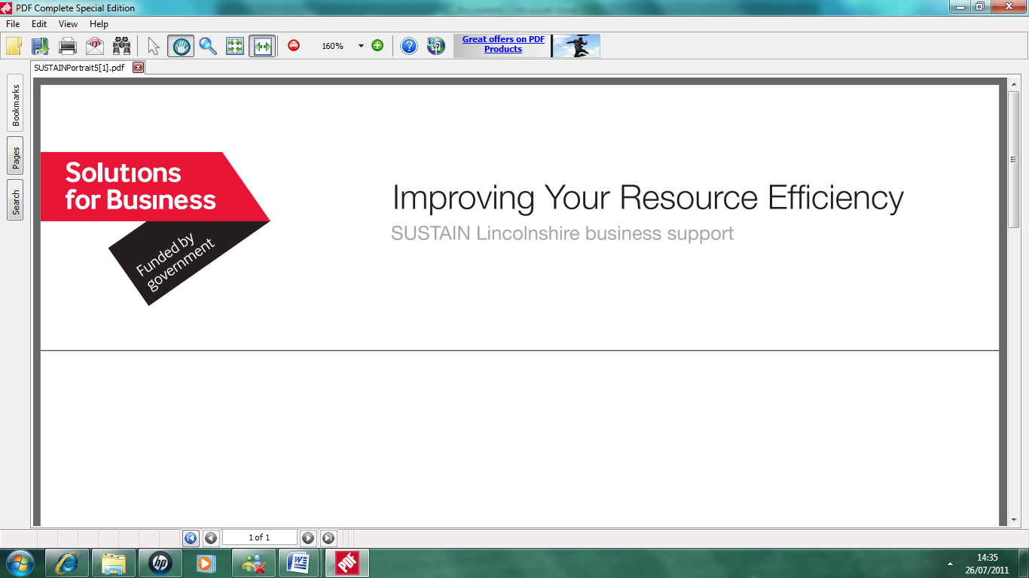

Improving Your Resource Efficiency
Sustainability in Packaging

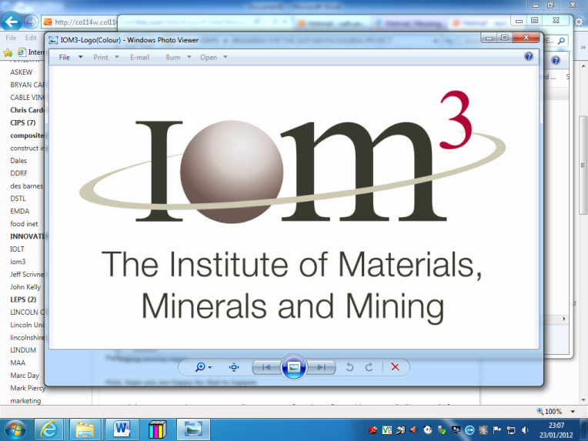
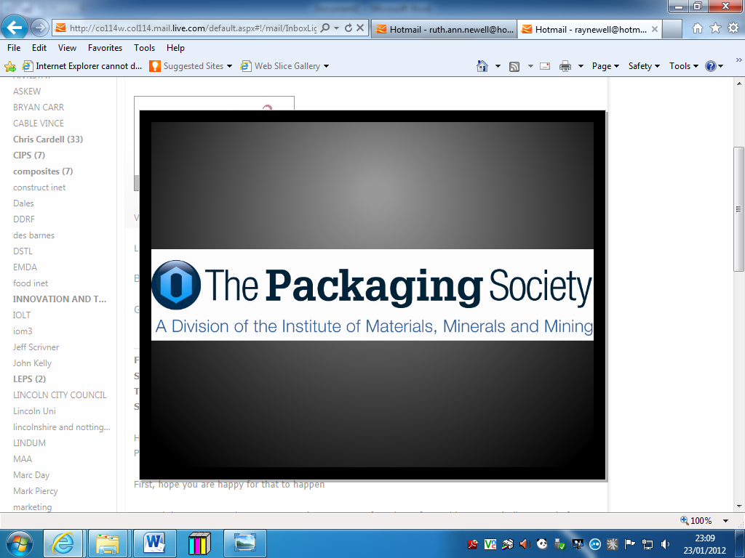


Oakwell Management
Services Limited

CREATING INNOVATION IN SUSTAINABLE PACKAGING

Lincolnshire County Council’s SUSTAIN Lincolnshire programme is supporting research into the effects that packaging has on Lincolnshire SME’s, and through the stimulation of innovations in packaging, identify solutions that will save valuable resources, produce less waste, save money and increase profits.
To stimulate innovation in SME’s Lincolnshire County Council is working in collaboration with the Institute of Minerals, Mining and Materials (IOM3), The Packaging Society, University of Lincoln and Oakwell Management Services Limited. The collaborative team have chosen to find the best ideas in sustainable packaging by holding a competition, which will be carried out in the following way:
- Companies interested in providing innovative ideas and concepts will be asked to provide an initial conceptual description on the form attached. From all the entries received a dozen will be selected by a panel of experts by end June 2012
- The twelve selected companies will be offered the opportunity to develop their proposed ideas in theory, in the form of a written proposal and presentation with the assistance of a grant of up to £1,000 and access to expert advice by end July 2012
- Following the development of the proposed ideas, the applicants will ‘pitch’ to a panel of experts, who will select the final four best ideas.
- The final four competitors will be offered a further grant of up to £2,500 to create a prototype of a product/process for demonstration to companies by end October 2012.
- The final idea will be selected by a panel of experts (led by the East Midlands Packaging Society), and used to develop a demonstrator project to be retained at the IOM3 facility in Grantham, aimed at demonstrating the benefits of the selected idea to a wider audience.

There is no restriction on the materials or processes involved in the packaging ideas. For example they could be plastic, wood, paper, glass or metal, or alternatively management, quality assurance or procurement, but sustainability must be your guide when applying.
The competition is open to any SME in Lincolnshire, so if that is you, and you have a great idea about how packaging can be made more sustainable, please apply now on the attached form. Once you have applied one of our experts will contact you to help you to put your full proposal together.
We look forward to your help in making Lincolnshire a centre of excellence for ideas in sustainable packaging.

Contact: Mark Swainson mswainson@lincoln.ac.uk 01406 493 038


Improving Your Resource Efficiency
Sustainability in Packaging

Oakwell Management
Services Limited

SUSTAINABLE PACKAGING COMPETITION SUBMISSION

Company Name

Address

Nominated Contact/
Project Leader
Type of Business

Packaging Category : User/ Manufacturer/Designer

Project details

Date of submission
Signature of applicant

Please return this form electronically to mswainson@lincoln.ac.uk With regard to the “Signature of applicant” section e-Mail applications will be considered as “signed digitally” (there is no need to scan a copy).

