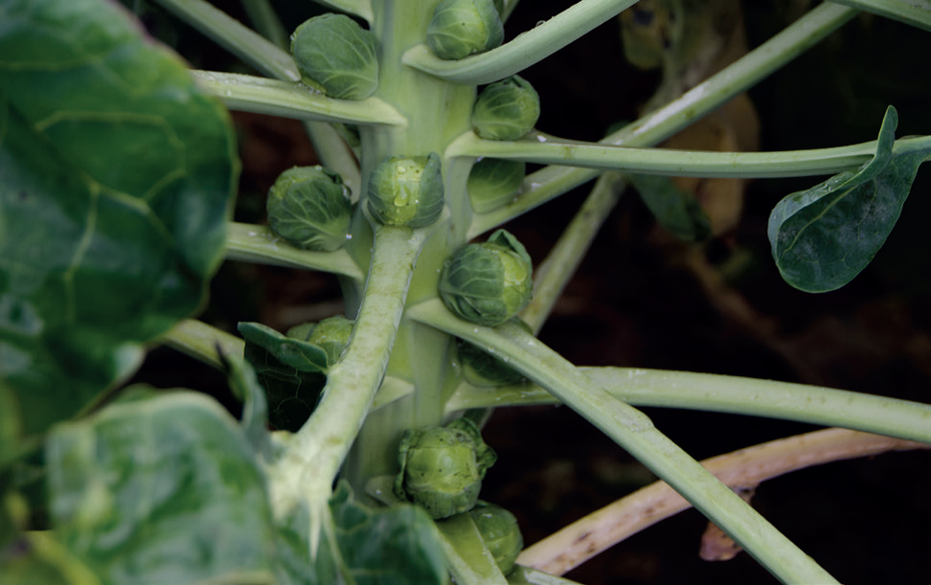

Agri-Food Trainee Scheme Application
_________________________________

First Name
Surname
Address

Contact Number

Email Address

Most recent secondary school or college attended

School/College

Address
Dates attended

Subject/qualification at A or AS level
Please highlight where grades are predicted*

Subject |  | Qualification | Grade | Year

Subject/qualification at GCSE level
Subject | Qualification | Grade | Year

Work Experience Profile – please detail and work experience undertaken at School or outside of your formal education programme
(Most recent first, please continue on a separate sheet if required)

Employer | Type of Work | From Date | To Date | Voluntary Work (Y/N)

About you – what are your hobbies, interests or achievements?

x

Why do you wish to apply for the Produce World Agri-Food Trainee Scheme?

Some of our sites are not readily accessible by public transport.
Do you have a means of travel?

Please post, email or scan your application by 31st March 2015 to:

Mrs Sharon Green
Head of Skills and Work Based Learning
The National Centre for Food Manufacturing
University of Lincoln
Holbeach Campus
Park Road
Holbeach
PE12 7PT
01406 493000 or 07843658937
shgreen@lincoln.ac.uk
www.lincoln.ac.uk/ncfm
Follow us on Twitter @HolbeachNCFM Find us on Facebook www.facebook.com/NCFMHolbeach

