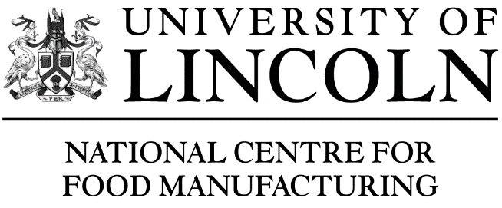
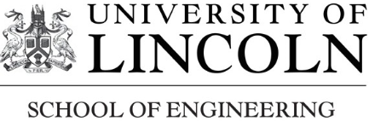

HIGHER & DEGREE APPRENTICESHIPS FOR FOOD ENGINEERS

Employer Consultation
26th March in the Conference Room (NCFM Building)

NCFM in partnership with the University’s School of Engineering are keen to consult on the proposed content and mode of delivery of the following qualifications to underpin the newly approved standard for the Advanced Food Engineer Degree Apprenticeship and the planned Food Engineering Higher Apprenticeship and would very much welcome the input of Food Engineering Managers.

12.30 | Arrival & Lunch
13.00 | Welcome, Introductions, overview and update of Higher and Degree Apprenticeships landscape  - Introduction to NCFM and the Lincoln School of Engineering  - Overview of the full apprenticeship development framework  - Food Engineering apprenticeship standards | Professor Val Braybrooks  Dean of NCFM
13.20 | Delivery discussion -  - Content  - Assessment | Dr Mike Gallimore  Keith Brewood  Isabel Campelos
14.00 | Mode of delivery and student support  - Mode of attendance – balancing attended sessions and distance learning  - Demonstration of the DL platform (Blackboard) and OneFile  - Requirements for teaching and student support | Vanessa Sutton  Alex Borman
15.00 | Progression and recruitment  - Progression from the Level 3 Food and Drink Engineering Maintenance Apprenticeship  - Apprenticeship recruitment | Sharon Green
15.30 | Plenary and next steps
16.00 | Depart

